Market and Patent Research Report
Topic: Autonomous Robotic Systems for the Removal of Invasive Plant Species
Case Study: Giant Hogweed and Similar Neophytes
Course: Product Development – From Need to Market
Institution: Hochschule Kaiserslautern
Semester: SS 2025

1. Introduction
Invasive alien plant species such as Heracleum mantegazzianum, Lupinus polyphyllus, and Jacobaea vulgaris pose significant environmental and public health challenges in Europe. These plants negatively affect native biodiversity, outcompete local flora, and may pose toxicological risks to humans and animals. Conventional removal methods rely on herbicides, which are increasingly restricted by EU environmental legislation (e.g., Regulation (EU) No. 1143/2014), or labor-intensive mechanical clearing.
Recent advances in agricultural robotics provide an opportunity to address this issue using autonomous systems that employ machine learning, vision technologies, and non-chemical removal techniques, including electric pulse applications.

2. Market Overview and Technological Landscape

2.1. RootWave (UK) – Electric Weed Control System
- Technology: Applies high-frequency electric pulses through contact probes to thermally destroy plant cells from root to tip.​
- Target Species: Effective on deep-rooted perennials including Heracleum mantegazzianum.​
- Advantages:
  - Non-chemical and environmentally safe.​
  - Minimal soil disturbance.​
  - Suitable for robotic integration.​Carbon Robotics
- Use Cases: Municipalities, ecological reserves, organic agriculture.​

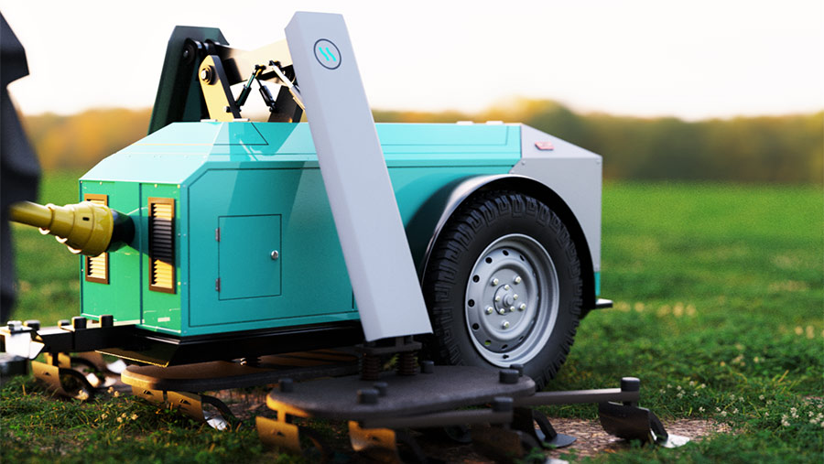

- Video Demonstration:
RootWave Demonstration​1
RootWave Demonstration​2

2.2. Carbon Robotics – LaserWeeder

- Technology: AI-powered machine vision with mounted CO₂ lasers for precision weed eradication.​
- Limitations: Not designed specifically for tall or toxic plants like hogweed; more suitable for row crops.​
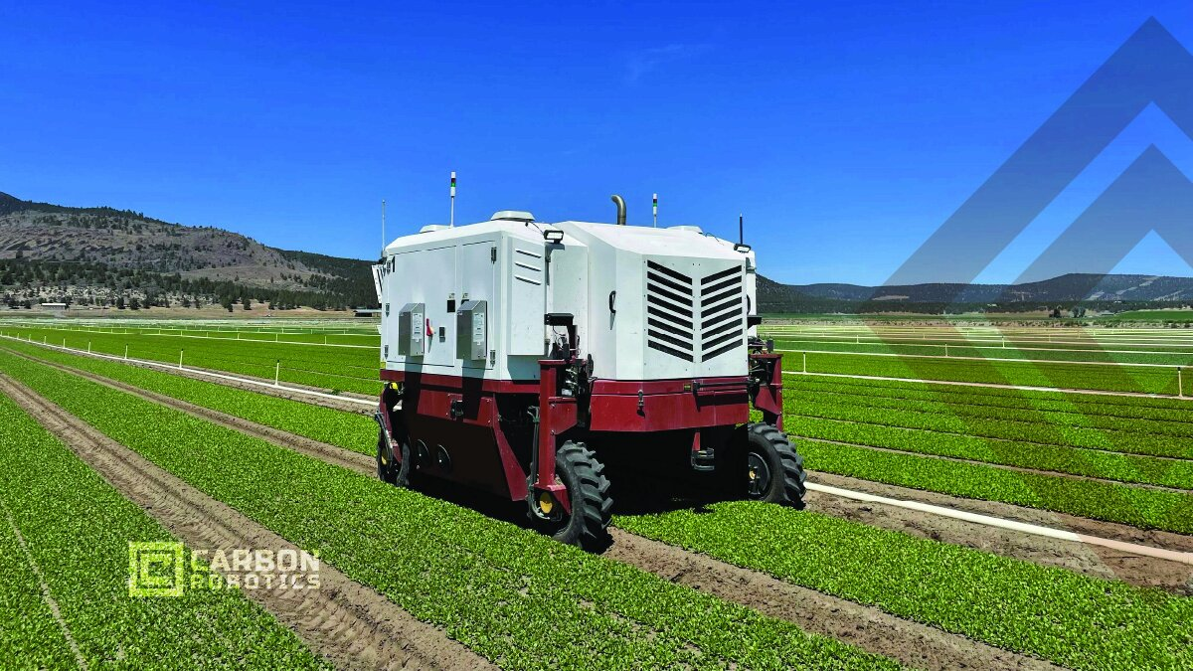
- Video Demonstration: LaserWeeder Overview​

2.3. Odd.Bot – Weed Pulling Robot (NL)
- Technology: Selectively detects and pulls weeds using robotic grippers, based on image classification algorithms.​
- Suitability: Applicable for broadleaf weed species like Jacobaea vulgaris.​

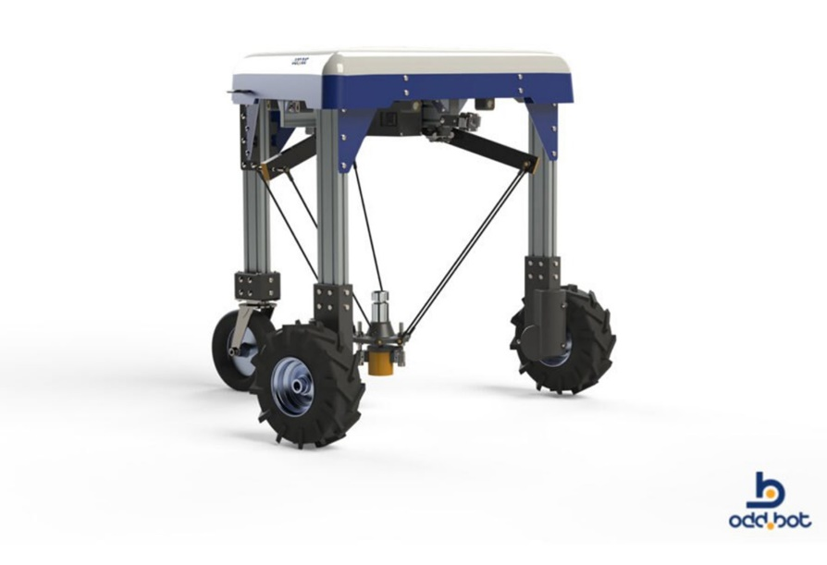

2.4. Drone and Aerial Detection Platforms (DK, DE, UK)

- Application: Drones combined with NDVI, hyperspectral imaging, or machine learning can map infestations of hogweed in open fields and forests.​
- Complementary Role: Ideal for pre-mapping and targeting robotic ground intervention.​

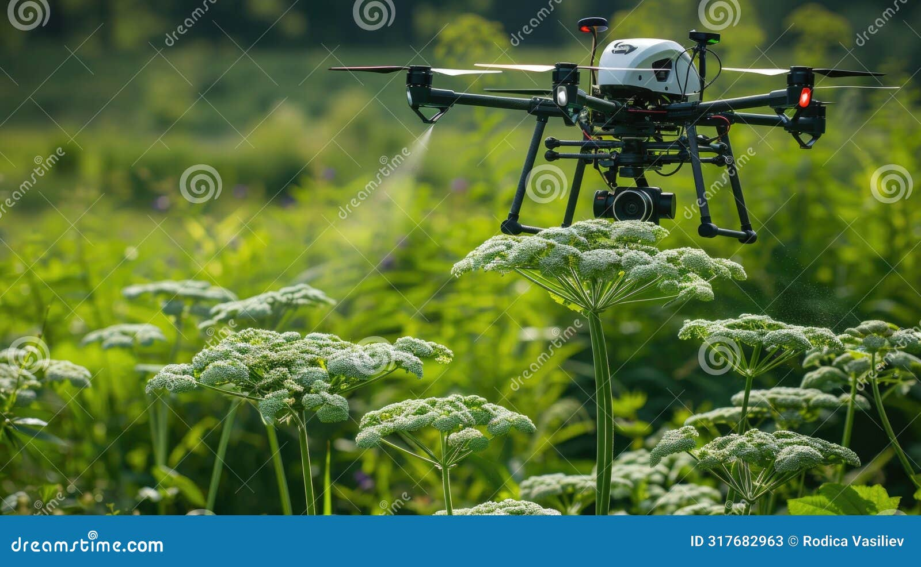

2.5 FarmWise Titan FT-35 (USA)
FarmWise (manufacturer)
Technology: self-driving robotic cultivator with multi-camera computer vision and trained AI and mechanical blades. (The system can also spot-apply chemicals like fertilizer or pesticides if needed.)

2.6 Naïo Technologies “Dino” (France)​
Naïo Technologies (manufacturer)
Technology: GPS guidance, lasers, and cameras to localize itself and follow crop rows. Dino does mechanical weeding with adjustable harrows and hoeing tools that uproot weeds between crop rows. It can optionally use machine vision (as on Naïo’s smaller Oz robot) to detect crop rows or plants and skip crop plants while cultivating around them.

2.7 ecoRobotix AVO (Solar Weeding Robot) (Switzerland)
ecoRobotix (manufacturer)
solar-powered autonomous rover that identifies weeds and spot-sprays them with micro-doses of herbicide. AVO uses cameras and AI software to differentiate weeds from crops at the ground level. When a weed is detected, a robotic arm with a small spray nozzle precisely applies a few drops of herbicide onto the weed, minimizing chemical usage. (In tests it initially recognized two crop types – sugar beets and canola – and treated weeds in those fields.)

2.8 FarmDroid FD20 (Denmark)
FarmDroid (manufacturer)
it records the GPS coordinates of each seed it plants, then later weeds the field based on those known positions. It is a solar-powered autonomous planter/weeder that first sows crops in precise grid patterns. During weeding, it does blind mechanical cultivation both between rows and within rows – any plant not at a recorded crop position is assumed to be a weed and is cut by its small hoes. This eliminates weeds even very close to the crop seedlings, without needing cameras.

2.9 Small Robot Company “Tom & Dick” (UK)
Small Robot Company (startup)
This UK-based system uses two robots in sequence. Tom is a lightweight scouting robot that autonomously maps the field, using cameras to capture detailed images of crops and weeds. The data is processed by an AI engine (nicknamed “Wilma”) which uses pattern recognition to distinguish weed seedlings from crop plants. Then Dick, the killing robot, navigates to the weed locations. For removal, Dick uses an electrical weeding system: it precisely positions a small electrode probe above each weed and delivers an ~8,000-volt electric shock to “boil” the weed from the roots. The weed-zapping arm is mounted on an igus delta robotic arm for speed and accuracy, and multiple arms can operate in parallel.

2.10 AutoWeed (JCU) – Lantana Targeting Robot (Australia)
James Cook University research (Australia)
Originally developed as a PhD project, this prototype robot focuses on spotting and spraying Lantana camara, a highly invasive shrub in Australia. It carries eight cameras feeding an onboard image processing AI. The system uses color (green vs brown), leaf shape, and texture analysis to identify the target weed (lantana) among native vegetation. When it recognizes lantana, it uses a mounted sprayer to apply a targeted dose of herbicide directly onto that plant. The robot navigates autonomously (currently towed or escorted by an ATV during tests) and geo-tags the locations of sprayed weeds via GPS for record-keeping.

2.11 BirdHabitatBot (UConn) – Forest Invasives Robot (USA)
BirdHabitatBot (UConn startup project)
BirdHabitatBot is a prototype system aimed at forest understory invasive shrubs, specifically Japanese barberry and multiflora rose in Northeast U.S. forests. The approach uses drones for detection and a ground robot for removal. First, a drone surveys the forest in early spring (a brief window when the invasives leaf out before native plants). Using deep learning, the system analyzes aerial images to identify patches of the target invasive plants by their spectral and textural signatures in the understory. These locations are mapped (GPS coordinates). Then a mobile robot (“BirdBot”) navigates to those coordinates on the forest floor to physically cut the invasive plants at the base. The removal robot is being designed to safely traverse leaf litter, rocks, and saplings to reach each plant and cut or pull it out.

2.12 Bosch Deepfield “BoniRob” (Germany)
Bosch (Farming – research prototype)
Uses Camera vision distinguishes weed seedlings by leaf shape with A piston punches weeds into soil (“stamping” method). No chemicals; very fast actuation (up to 1.75 weeds/sec). Prototype not commercialized; requires small weed size; heavy platform with generator
2.13 “Hydrilla Hunter” Robotic Boat (USA)
Northeastern University & Connecticut Ag. Experiment Station
Aquatic – freshwater weeds with Hyperspectral camera detects unique spectral signature

Comparison Table of Weed Removal Robots
Robot (Origin) | Environment & Use | Recognition & Mapping | Removal Mechanism | Key Pros | Key Cons
Carbon LaserWeeder G2  (USA) | Farming – row crops (vegetables, row herbs) | Cameras + deep-learning AI distinguish crops vs weeds | 8× high-powered lasers “zap” weeds (no contact) | No herbicides; no soil disturbance; fast, day/night​ | Expensive; heavy tractor mount; limited to spaced row crops
FarmWise Titan FT-35  (USA) | Farming – vegetable fields | Multi-cameras + AI model trained on millions of images | Automated blades cut weeds around crop plants | Chemical-free weeding; adaptable to many crops; as-a-service model | Large machine; requires row structure; service fees (not owned)
Naïo Dino  (France)​ | Farming – vegetable bed weeding | GPS guidance + front laser/camera for row positioning​ | Mechanical cultivator blades/hoes uproot weeds | Battery-electric (6–8h); reduces hand labor; multi-task capable | Heavy unit; high upfront cost; mainly inter-row (in-row weeds harder)
ecoRobotix AVO  (Switzerland) | Farming – precision spot-spraying | Camera vision + AI to detect weeds among crops | Micro-dose herbicide sprayer on robotic arm | Solar-powered; uses 95% less herbicide; light & low compaction | Slow coverage; limited initial crop/weed range; not for tall crops
FarmDroid FD20  (Denmark) | Farming – seeding & weeding | RTK GPS maps crop seed positions (no vision needed) | Tiny harrows weed between and within rows mechanically | No camera needed (simple); zero chemicals; 24/7 solar run | Must use robot for planting; slow but steady; limited to row crops
Small Robot Co. Tom/Dick  (UK) | Farming – arable crops (trials) | “Tom” maps field with cameras; AI (Wilma) identifies weeds | “Dick” robot zaps weeds with 8kV electrical probe | No herbicides; can selectively leave benign plants; little soil impact | Prototype stage; two-step process is time-consuming; complex multi-robot system
AutoWeed Lantana Robot  (Australia) | Rangeland/Forestry – invasive shrubs | 8 RGB cameras + AI vision (color/shape/texture) find target weed | Sprays herbicide on detected weed foliage via nozzle | Cuts labor & cost for weed crews; 90% ID accuracy in tests | Prototype (tethered in tests); uses chemicals; terrain navigation challenges
BirdHabitatBot  (USA) | Forestry – understory invasives | Drone aerial imagery + deep learning to map invasive shrubs | Ground robot drives to locations and cuts shrubs at base | Targets only invasives (protects natives); keeps workers safe | Experimental; rough terrain obstacles; may need supplementary herbicide for stumps
Hydrilla Hunter  (USA) | Aquatic – freshwater weeds | Hyperspectral camera detects unique spectral signature | Marks GPS coordinates of hydrilla patches (for later removal) | Automates weed surveys; very species-specific (few false alarms) | Doesn’t remove weed itself; limited battery; one-species focus (Hydrilla only so far)
Bosch Deepfield “BoniRob”  (Germany) | Farming – research prototype | Camera vision distinguishes weed seedlings by leaf shape | A piston punches weeds into soil (“stamping” method) | No chemicals; very fast actuation (up to 1.75 weeds/sec) | Prototype not commercialized; requires small weed size; heavy platform with generator

3. Patent Research Overview

3.1. EP3804483A1 – Tool for Eradication of Invasive Hogweed Species

- Assignee: Søren Lauritzen (Denmark)​
- Description: Manual stem-puncturing tool to induce necrosis in giant hogweed without full severing. Minimizes regrowth by damaging vascular tissues.​
- Significance: Basis for potential robotic adaptation using automatic puncturing probes.​
- Link: Patent EP3804483A1​

3.2. WO2021055485A1 – Autonomous Laser Weed Eradication System

- Assignee: Carbon Robotics​Dreamstime+3Log in or sign up to view+3GeekWire+3
- Description: Robotic platform with sensors and vision system guiding a laser source to ablate unwanted plants.​
- Limitation: Not optimized for toxic plants or non-row field applications.​
- Link: WO2021055485A1​

3.3. US20170238460A1 – Weeding Robot and Method

- Assignee: Blue River Technology​
- Description: Selective weeding robot using capacitive and optical sensors for precision removal using mechanical tools.​
- Potential Use: Adaptable platform for invasive species differentiation and removal.​
- Link: US20170238460A1​

3.4. EP3744173A1 – Weed Inactivation Device Using Electric Pulses

- Assignee: Zasso GmbH (Germany)​
- Description: Electrically driven weed inactivation device using contact electrodes for plant-specific destruction.​
- Relevance: Can be integrated into autonomous platforms for field use against large invasive targets.​
- Link: [EP3744173A1]( https://patents.google.com/patent/EP3744173A1/en

